***Air Mobility Command***

**STATEMENT OF WORK FOR**

**SECURE STORAGE AREA**

**BUILDING 3192, ROOM 101**

**AT**

**SCOTT AFB, ILLINOIS**

1. SCOPE OF WORK: The contractor shall procure and provide all personnel, equipment, tools, materials, vehicles, supervision, and other items and services necessary to fabricate and install a new security enclosure under the Mezzanine in Building 3192, room 101, as shown in Appendix A, in a manner that creates a secure storage area. There is no need for the contracted workers to have special clearance above what is required to gain entrance to the military installation, because once inside Bldg. 3192, they will always be escorted by at least one government employee. The contractor shall perform to the standards in the contract, as well as all local, state, federal regulations, and appropriate Final Governing Standards (FGS).
2. PLACE OF PERFORMANCE: Scott AFB, IL, 3111 East Drive, Building 3192, Room 101.
3. REQUIREMENTS: The Contractor shall procure, fabricate (as required), and install all items necessary to enclose the area under the Mezzanine so that it effectively creates a secure storage area that replicates a freestanding security cage, as stipulated in this Statement of Work (SOW) and according to the room layout design as shown in Appendix A, to include but not limited to:
   1. Procure specified security panels, framing, locking door(s), and material as specified in Appendix A and meet Period of Performance (PoP) of 90 days. All hardware must be installed and the project declared finished within 90 days of contract acceptance.
   2. Contractor must provide schedule with bid package to include, at minimum, the following key milestones:
      * Approval of final finish selections
      * Itemized description of product/quantities ordered
      * Manufacturing period
      * Shipping/delivery details
      * Teardown
      * Installation
      * PoP (90 days – must work rest of schedule to fit with date)
   3. Hardware and materials used to enclose the area under the Mezzanine, once fully installed, shall not block or render unusable any stationary equipment already in-place prior to start of work. Examples of stationary in-place equipment include: stairwell leading to upper level of Mezzanine, wall-mounted electrical outlets/electrical panels, air compressor tank, all under Mezzanine lighting fixtures, and the light switch that powers on the lighting fixtures.
   4. Keep the work site clean, remove any debris daily and at the completion of the project, remove all debris, sweep, and vacuum the site.
   5. All work will take place during normal business hours (0830-1630), Monday – Friday. Differing start and end times must be coordinated with the Contracting Officer.
4. PERFORMANCE STANDARD: The contractor shall fabricate and install secure storage area components, door(s) with lock, and related material as displayed in Appendix A and consistent with this SOW. The security cage panels, door(s) with lock, and related material will maintain the same state/condition after installation as before the installation.
5. INSURANCE/PROTECTION: The Contractor is responsible for all damage (if any) done during the performance of this contract.
6. PAYMENTS: The Government will not make advance payments or progress payments. All costs will be inclusive and paid in one lump sum, in arrears. Payments will be made using Wide Area Work Flow (WAWF).
7. GOVERNMENT CONTRACTOR: The Contractor and their employees shall perform services under this contact in accordance with the terms and conditions of this contract, including the SOW, as a contractor and not as a Government agent or employee or joint venture. The Contractor and employees are employed to render professional fabrication and installation services only, and any payment made by the Government is compensation solely for such services rendered.
8. SECURITY REQUIREMENTS: Contractor employees shall comply with any base security measures implemented at all times. This includes but is not limited to vehicle and goods searches and identification checks during times of increased security.

**Contractor Consent to Background Checks:** The contractor and, as applicable, subcontractor shall not employ persons for work on this contract if such employee is identified as a potential threat to the health, safety, security, general well-being or operational mission of the installation and its population, nor shall the contractor or subcontractor employ persons under this contract who have an outstanding criminal warrant as identified by Law Enforcement Agency Data System (LEADS) through the National Crime Information Center. LEADS checks will verify if a person is wanted by local, state, and federal agencies. All contractor and subcontractor personnel must consent to LEADS background checks. Contractor and subcontractor personnel who do not consent to a LEADS check will be denied access to the installation. Information required to conduct a LEADS check includes: full name, driver’s license number, and/or social security number, date of birth of the person entering the installation, and completion of a background check questionnaire. The contractor shall provide this information using the Scott AFB Form 21, Contractors Consent for Background Check, and shall submit it in conjunction with the contractor’s request for either base or vehicle passes. Completion of a successful LEADS check does not invalidate the requirement for an escort when contractor or subcontractor personnel are working within controlled or restricted areas.

Contractors shall ensure their employees and those of their subcontracts have the proper credentials allowing them to work in the United States. Persons later found to be undocumented or illegal aliens will be remanded to the proper authorities. The contractor shall not be entitled to any compensation for delays or expenses associated with complying with the provisions of this clause. Furthermore, nothing in this clause shall excuse the contractor from proceeding with the contract as required.

**Contractor Registration of Vehicles on Scott AFB:** All contractor or contractor employees’ vehicles used for the performance of this contract shall comply with all local, state and federal regulations.

Additionally, any pass shall be surrendered to Security Forces upon demand to positively identify a person’s need to be on Scott AFB.

**Access to Installation during Force Protection Conditions (FPCONs):** Contractors will be assigned a mission essential designation IAW requirements contained in Scott Air Force Base Integrated Defense

Plan 31-1. Only the installation commander or the unit commander requesting contract support will assign the mission essential designation.

### Contractors Working in Controlled or Restricted Areas:

The unit requesting contract support will provide escort(s) for contractors at all times when within a controlled area. Contractors shall not escort other contractor employees within controlled or restricted areas. In addition, contractors shall fulfill, maintain, and comply with all security requirements IAW Scott Air Force Base Integrated Defense Plan 31-1, and command/local directives.

### Access to Government Facilities with Controlled or Restricted Areas:

The contractor shall comply with security regulations imposed by the installation commander and/or the agency responsible for the project location. Due to specific mission requirements inherent in the nature of controlled or restricted areas on Scott AFB, the government may direct the contractor to leave the controlled or restricted areas at any given time.

Attachments:

Appendix A - Proposed Secure Storage Area Layout, Building Bldg. 3192, Room 101 AMC/A3CG

**Appendix A**

Building 3192, Room 101

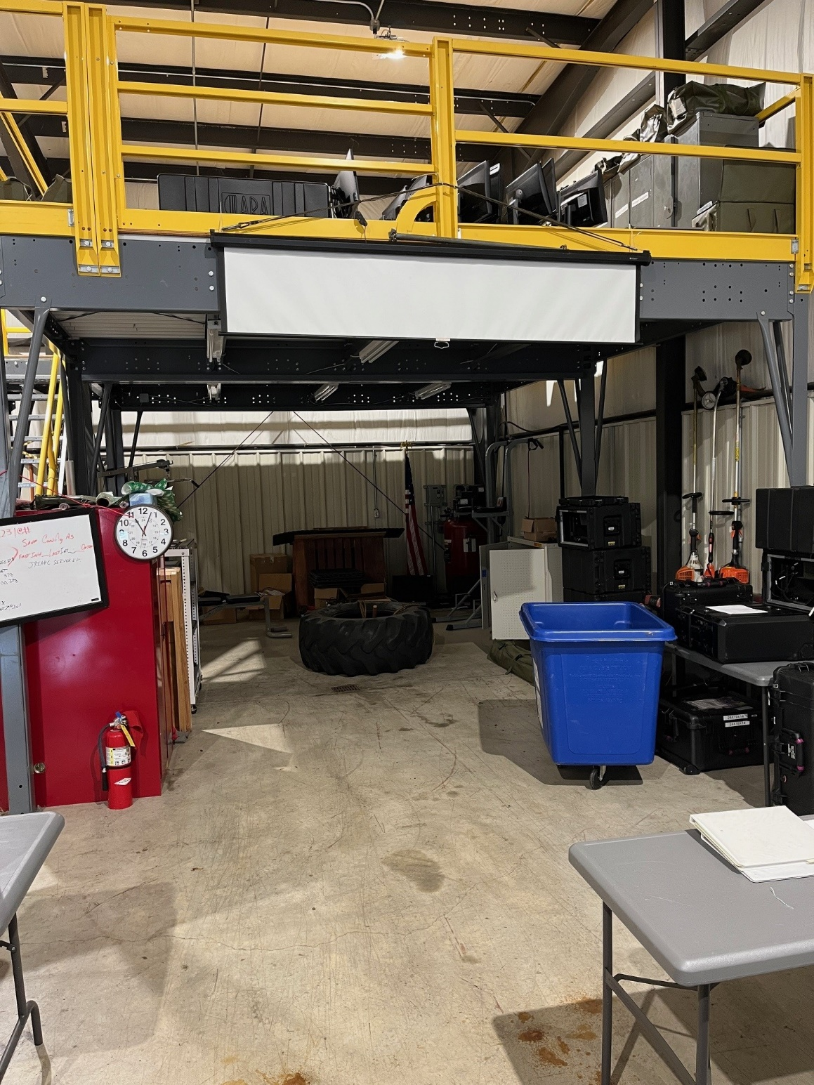 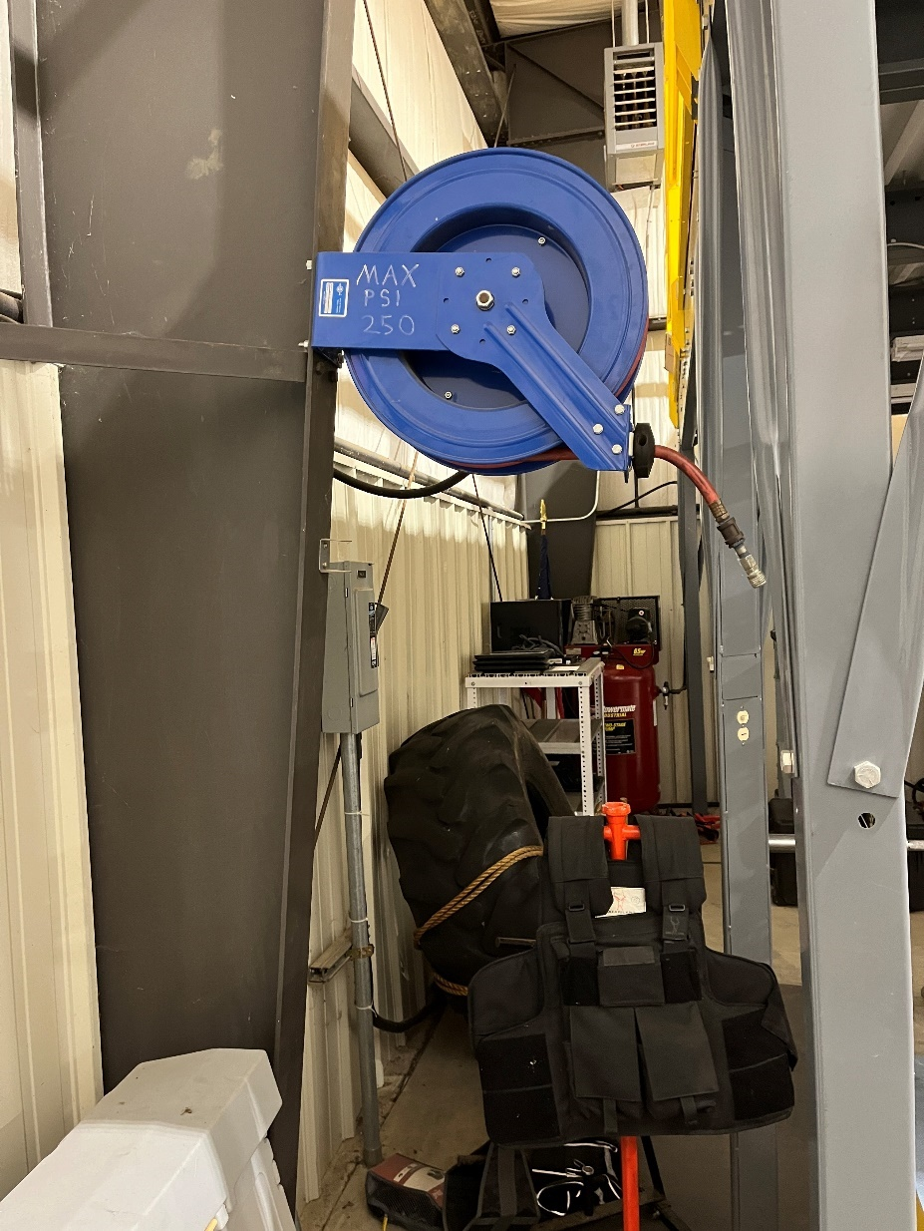

Overhead Floorplan of First Floor

Components:

* 1 x 24’ Long x 8.5’ High security wall (frame + panels)
* 1 x 16’ Long x 8.5’ High security wall (frame, panels, and sliding door opening)
* 1 x set of 8.5’ High sliding doors for 6’ opening, with Best lock core
* 1 x fabricated rigid ceiling panel frame for South side of Mezzanine, to prevent access to underneath of Mezzanine from upper level of Mezzanine
* 1 x set of binding/attaching hardware to interconnect and secure above-listed components to themselves and existing structural points in and around the Mezzanine
* 1 x labor package (fabrication & installation)